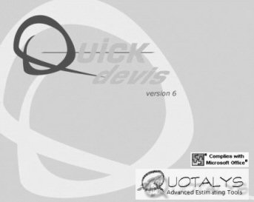
To create your own master documents, duplicate the file named QDMASTERDOCUMENT.DOT (which is located in your Quick Devis® installation directory) using the Windows explorer and create the document that meets your needs (you can add pictures, company names, project names…)
You can refefine styles but do not change their names. Do not remove any style. The bookmark named SUMMARY should remain in any of your master documents.
Your master documents should be .DOT files (Ms Word models)

SUMMARY

